BTT ACC (Altered Calling Criteria) Custom Component Quick Reference Guide

Developed for Analytics MPage

Date | Version | Description | Author | Role
29/11/2017 | 1.0 | Initial Draft | Javad Adeli | eMR Application Manager (PowerChart)

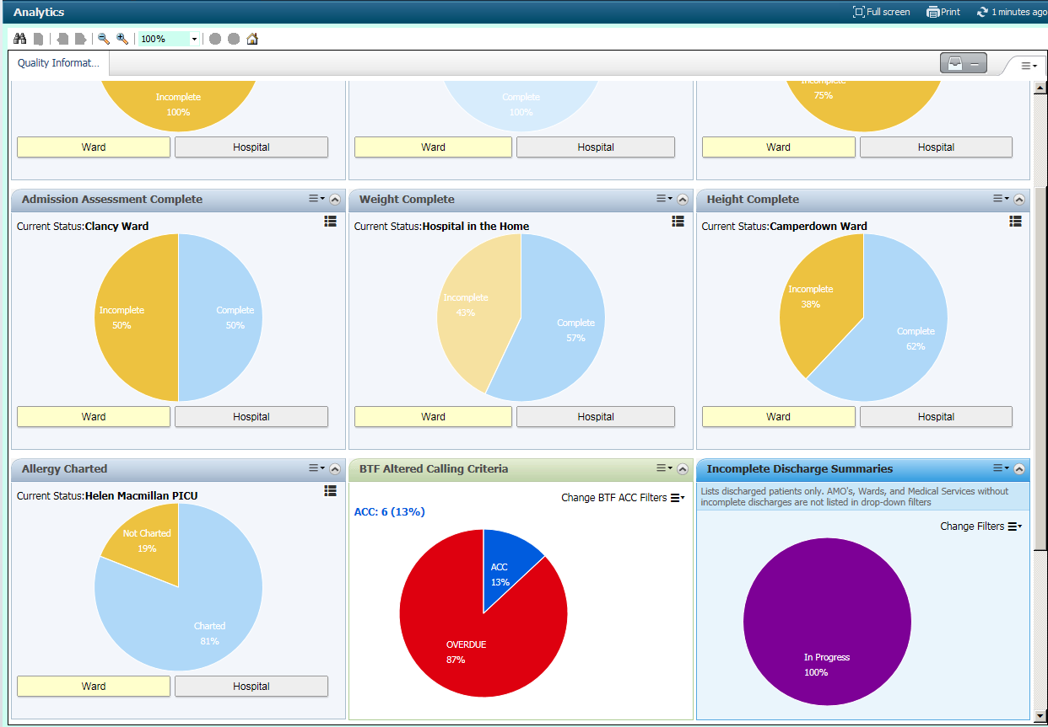

Overview

The BTF ACC component is a custom component developed for the Analytics MPage. It is following similar logics to the BTF – Altered calling Criteria report in explorer menu which audits the patients who have altered calling criteria recorded.
The BTF ACC component will display real time graph and data for patient who have altered calling criteria recorded in BTF Observation Chart and can be configured by using the filters to filter the results by facility, ward, encounter type, specialty and the attending medical officers’ name.

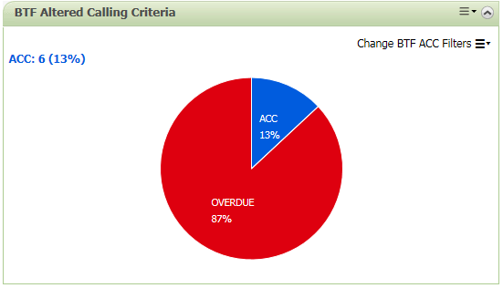

Using the BTF ACC Component

Afetr opening the Analytics Mpage located on the Organiser toolbar, the BTF ACC componenet will load all BTF ACC records for the defaulyt facility. Hovering the mouse cursor on different pie slices will display the total numbers and percents relevant to that chart on the top left hand corner of the componenet.
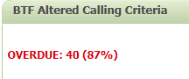

Click on the “change BTF ACC Filters” to expand the filters, and start to use the filiters if required.

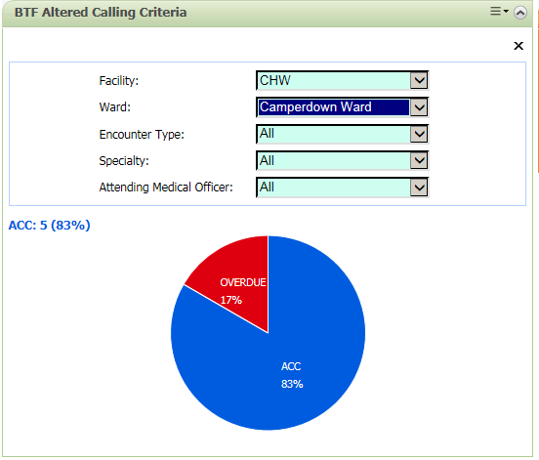
Changing the filters will instantly change the pie chart populated with the new data.

Click on each slice in the pie chart and the list of the patient relevant to that chart will display in a pop-up window with information related to the BTF ACC reordered for each patient.
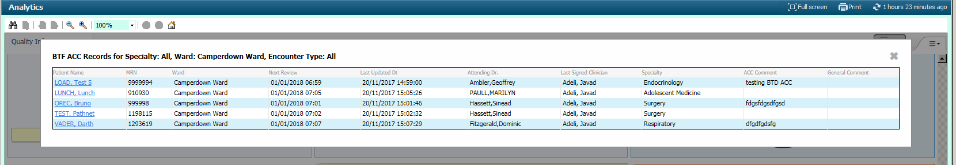

Click on the patient’s name hyperlinked in blue to open the patient’s chart in to the BTF observation chart tab and review for more details and assessment.

